|  |  |
| --- | --- |
| **AGENDA - Little Hoole Parish Council**  *Members of the Council are summoned to the Parish Council Meeting to be held on  Mon 10th March 2025 at 7:00pm*  ***The Lounge, Walmer Bridge Village Hall, Gill Lane, PR4 5GN*** Paul Cafferkey, Clerk & Responsible Financial Officer |  |

1. Apologies for absence
2. To agree the Minutes of the last Parish Council Meeting
3. To receive declarations of interest
4. Matters arising from the minutes of last meeting
   1. Public Time: to invite and listen to issues raised by members of the public.
   2. Planning Applications:
5. 07/2025/00093/HOH. 43 Hall Carr Lane PR4 5JJ. Two storey side and rear extension. Demolition of existing garage and construction of replacement garage/summer room with accommodation on first floor.
6. 07/2024/00382/FUL. Lower Marsh Farm Station Road PR4 5LH. Creation of a Slurry Lagoon.
7. 07/2025/00070/APD. 2 Pine Avenue, Land To South Pine Avenue PR4 5LB. Application to determine if prior approval is required for a proposed change of use of three agricultural buildings (nos. 2, 4 and 11) to general storage and distribution (under GPDO Schedule 2, Part 3, Class R).
8. 07/2025/00060/CLU. . 2 Pine Avenue, Land To South Pine Avenue PR4 5LB. Application for Lawful Development Certificate for existing use of storage for buildings 1, 3, 5-9 and 12-16 and existing use of stables for buildings 17 and 18.
9. 07/2025/00058/CLU. 42 Hall Carr Lane PR4 5JJ. Application for a lawful development certificate for an existing use of outbuilding for domestic storage.
   1. Planning Authority (SRBC) response to Parish Council letter re 07/2024/00889/FUL. Carver Hey Farm Moss Lane Little Hoole PR4 4SX. Demolition of Existing Buildings and Erection of 9 Detached Dwellings,
   2. To approve the following transactions in the bank for Jan & Feb 2025:

|  |  |  |  |
| --- | --- | --- | --- |
| Date | Payee | £ | Description |
| Current a/c | | | |
| 02-Jan-25 | Direct Debit (GOCARDLESS) | 36.96 | Monthly website fee |
| 10-Jan-25 | B/P to: SLCC | 110.00 | SLCC Annual subscription |
| 20-Jan-25 | B/P to: Employee 1 | 187.47 | Clerk's pay for tax mth 10 |
| 20-Jan-25 | B/P to: Employee 1 | 2.40 | Clerk's expenses for tax mth 10 |
| 23-Jan-25 | Direct Debit (HMRC SDDS) | 147.00 | Empoyee's tax to HMRC |
| 26-Jan-25 | Transfer to 20439596 | 20,000.00 | Trsf to parish Council Instant Access a/c |
| 27-Jan-25 | B/P to: McCluskey Window | 25.00 | Cleaning of bus shelters |
| 27-Jan-25 | B/P to: Employee 1 | 79.20 | Refund to Clerk re purchase of battery for defibrillator |
| 27-Jan-25 | B/P to: Little Hoole Schl | 2,000.00 | Grant to Little Hoole PTA re playground line markings |
| 27-Jan-25 | Much Hoole Parish Council | -1,875.00 | Income from Hoole Parish Council re purchase of lawn mower re Hoole Bowling Club |
| 31-Jan-25 | Service Charge | 6.00 | Monthly bank charge |
| 03-Feb-25 | Direct Debit (GOCARDLESS) | 36.96 | Monthly website fee |
| 03-Feb-25 | B/P to: Adam Watson | 20.00 | Work re barrel planters & Christmas Tree |
| 20-Feb-25 | B/P to: Paul Cafferkey | 171.79 | Clerk's pay for tax mth 11 |
| 28-Feb-25 | Service Charge | 6.00 | Monthly bank charge |
| Instant Access a/c | | | |
| 26Jan2025 | Transfer from 20435150 | -20,000.00 | Transfer from Parish Council Current a/c |

* 1. Payments approved by email or pre-approved and retrospectively noted – None.
  2. Payments for approval - Clerk’s claim for Feb 2025
  3. To receive the Clerk’s Financial Statement report as at 28th Feb 2025
  4. To review Standing Orders and Direct Debits
  5. To review signatories to the Parish Council Bank Account
  6. To approve the Parish Council’s Asset Register
  7. To approve the Parish Council’s Risk Register
  8. To consider the Central Lancashire Plan (Planning Document)
  9. To discuss fencing to the MUGA
  10. Grant to Walmer Bridge Village Hall – Update
  11. Community Orchard - Update
  12. Zip Wire project – Update
  13. Information and Updates.
  14. Correspondence
      1. email from member of public re out-of-date bus timetable.
      2. email from member of public: unable to access a NHS Dentist
  15. To agree the date, time, and venue for the April 2025 meeting.

**Members of the public are welcome to attend meetings to raise any relevant matters. Alternatively, if you cannot attend the meeting but wish to raise a matter or ask a question, this can be done on your behalf by contacting the Parish Clerk (Paul Cafferkey) via email at** [**clerk@littlehooleparishcouncil.org.uk**](mailto:clerk@littlehooleparishcouncil.org.uk) **or mobile phone 07966267186.**

Scan me to go to the Little Hoole Parish Council Website, or visit <https://www.littlehooleparishcouncil.org.uk/>

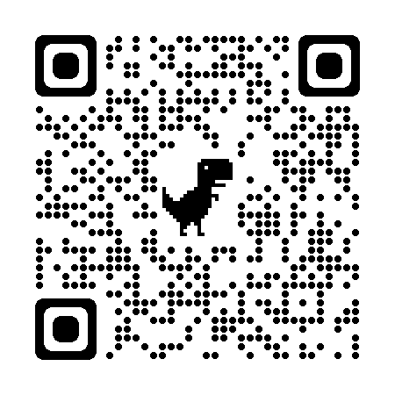

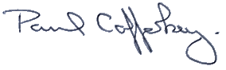Prepared and approved by Paul Cafferkey, Clerk – Little Hoole Parish Council,   
5th March 2025